Monday: God’s Story

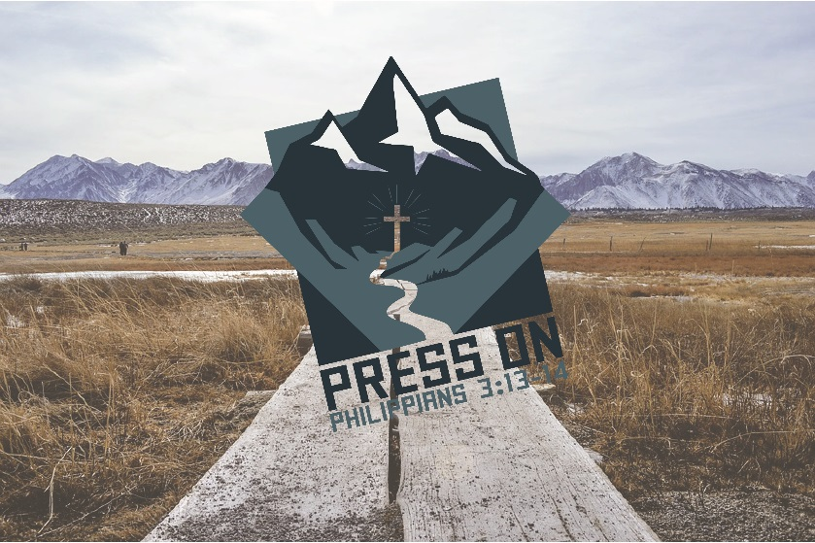
Objective: We are all a part of God’s story. He created everything and everyone. We fell away from Him, but God sent Jesus into the world to live, die, and rise again for each one of us. Our stories are therefore tied into God’s story, and we have a place in advancing the greatest story ever told.

Big Question: How does our story tie into God’s story?

Theme Verse: Revelation 22:13 - “I am the Alpha and the Omega, the First and the Last, the Beginning and the End.”

Main Story/Text: Acts 17:16-34 (Paul in Athens)

Main Points:
1. Everyone is a part of God’s story. (Acts 17:16-34)
Every day, we take part in the greatest story ever told, God’s story. He created the world and everything in it (Acts 17:24) through his son, Jesus Christ. He sent his son to die on the cross for our sins (Romans 3:21-24) and rise again (Acts 17:31-32). Through him, we have life (Acts 17:28 and John 3:16-17). Whether you know it, like it, understand it, or even care about it makes no difference. God has been working out his purpose since the beginning of time. (Colossians 1:13-17 and Colossians 3:1-4 summarize this well too)

2. God’s story is all about Jesus.
Every part of God’s story points to Jesus. He is the same yesterday, today, and forever (Hebrews 13:7-8). He is the beginning and the end of all things (Revelation 22:13). There is no one quite like our God (Psalm 86:8-10), and he is indeed good (Psalm 107:1-2).

3. We are called to take part in God’s story.
Just as the disciples were called to take part in the life and work of Jesus (Mark 1:14-20 and Mark 2:13-17), we get to take part in God’s story. Do you remember when you felt God’s call for you for the first time? God’s story didn’t end with the Bible. He continues to work in the world through his people and the power of his Holy Spirit. (John 16:7, 13-15)

Apply It:
(Throughout the week, we will be talking about how God’s story and our stories intersect. Today will be no different, although it may have more to do with God’s story in the Bible, rather than our own individual stories.)
- Talk about God’s story. Read and discuss what God has been up to since the beginning of time. What are some of the coolest parts of God’s story?
- Talk about how you felt God’s call on your life. When did God call you to be a part of his story? (You can answer this as well as your campers.) What happened to influence you in this way?
- Where do you see God’s story intersecting with your story?
- What are ways that you could see yourself advancing God’s story? (short term and long term)

Digging Deeper:
Jesus is throughout the entirety of the Bible, and the Bible points to Jesus.
Genesis 1 (Jesus was with God in the beginning. Verse 26-27 and the Word)
Genesis 22:1-14 (Jesus is the provided sacrifice.)
Numbers 21:36-9 (The snake on a pole was just like Jesus on the cross.)
Isaiah 53
Daniel 3 (Jesus was within the fire with Shadrach, Meshach, and Abednego.)
Micah 5:2 (Jesus will be born in Bethlehem.)

© 2019 Ingham Okoboji Lutheran Bible Camps
All rights reserved.

